Orchestration and Scaling: StreamingApp
-------------------------------------------------------------------------------------------------------------------------------
Submitted by:
Hari Prakash D (ID: 14313)
Batch: PPMCAD B17A
9916137763
hari.dprakash@gmail.com
https://github.com/Hariprakash-d/StreamingApp
-------------------------------------------------------------------------------------------------------------------------------
Objective
In this project you'll take a real multi-service MERN application, containerize it, ship it through a Jenkins CI pipeline to Amazon ECR, and deploy it to a production-style Kubernetes cluster on AWS (EKS) with monitoring, logging, and (optionally) ChatOps alerts layered on top.
Treat this as an end-to-end build: by the time you submit, the app should actually be running on your cluster, not just described in a doc.

Tools Installed:
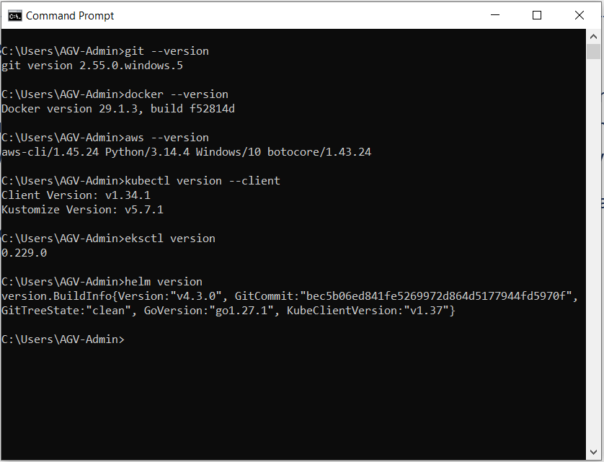

Hariprakash-d/StreamingApp forked from UnpredictablePrashant/StreamingApp:
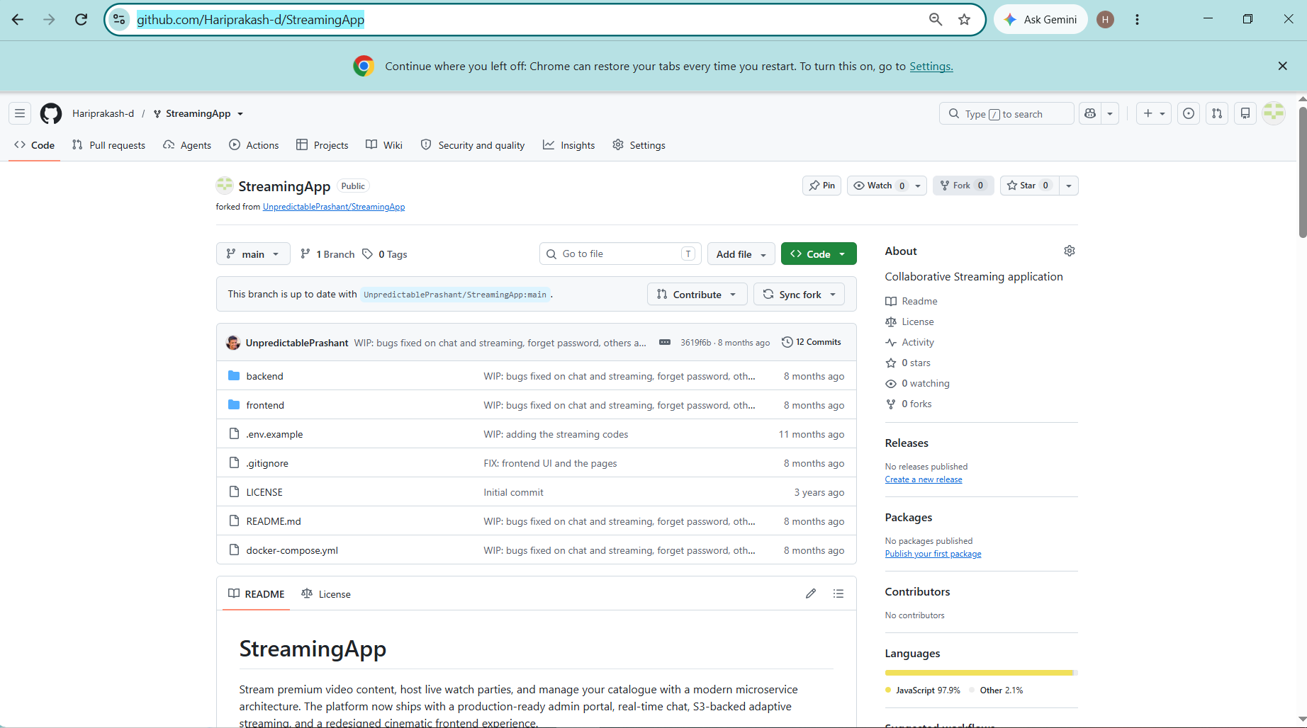

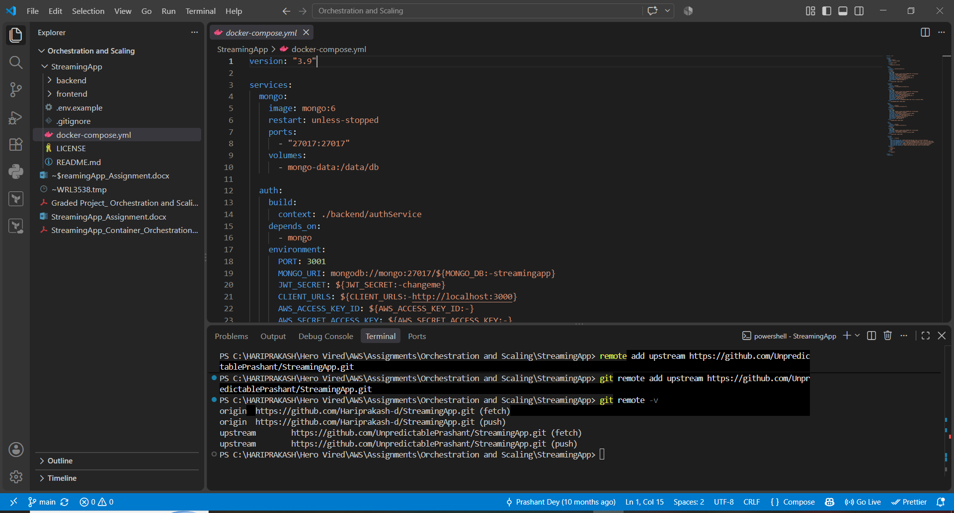

docker compose build
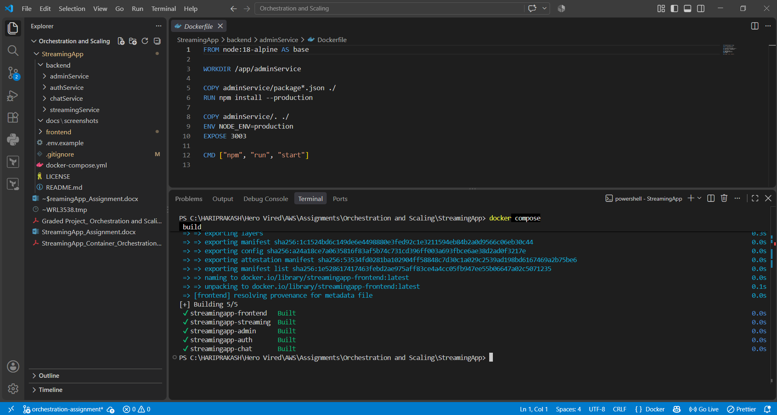
docker compose up -d
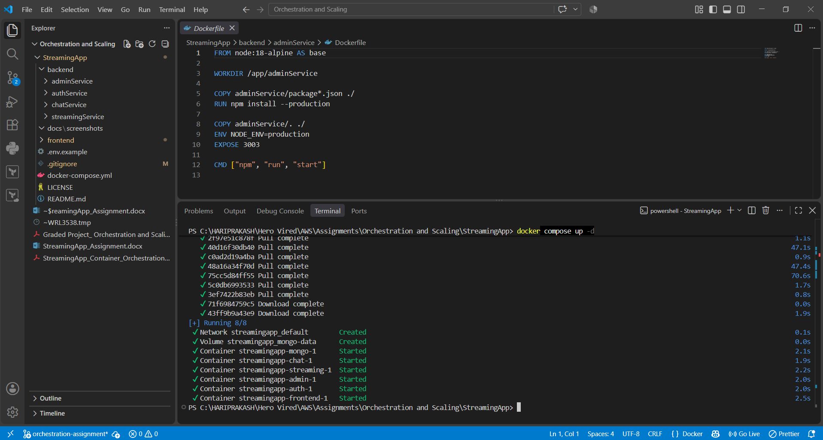

docker ps
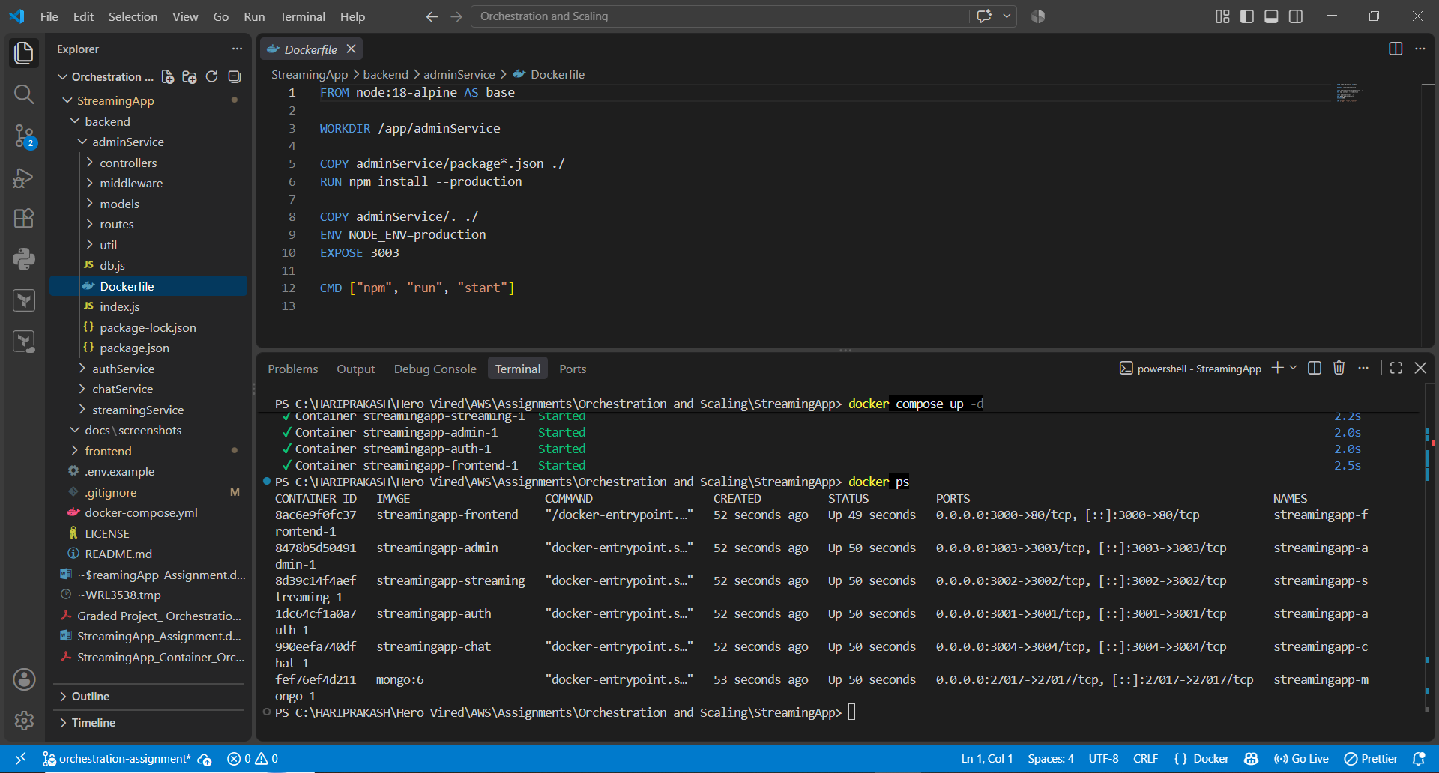
http://localhost:3000/
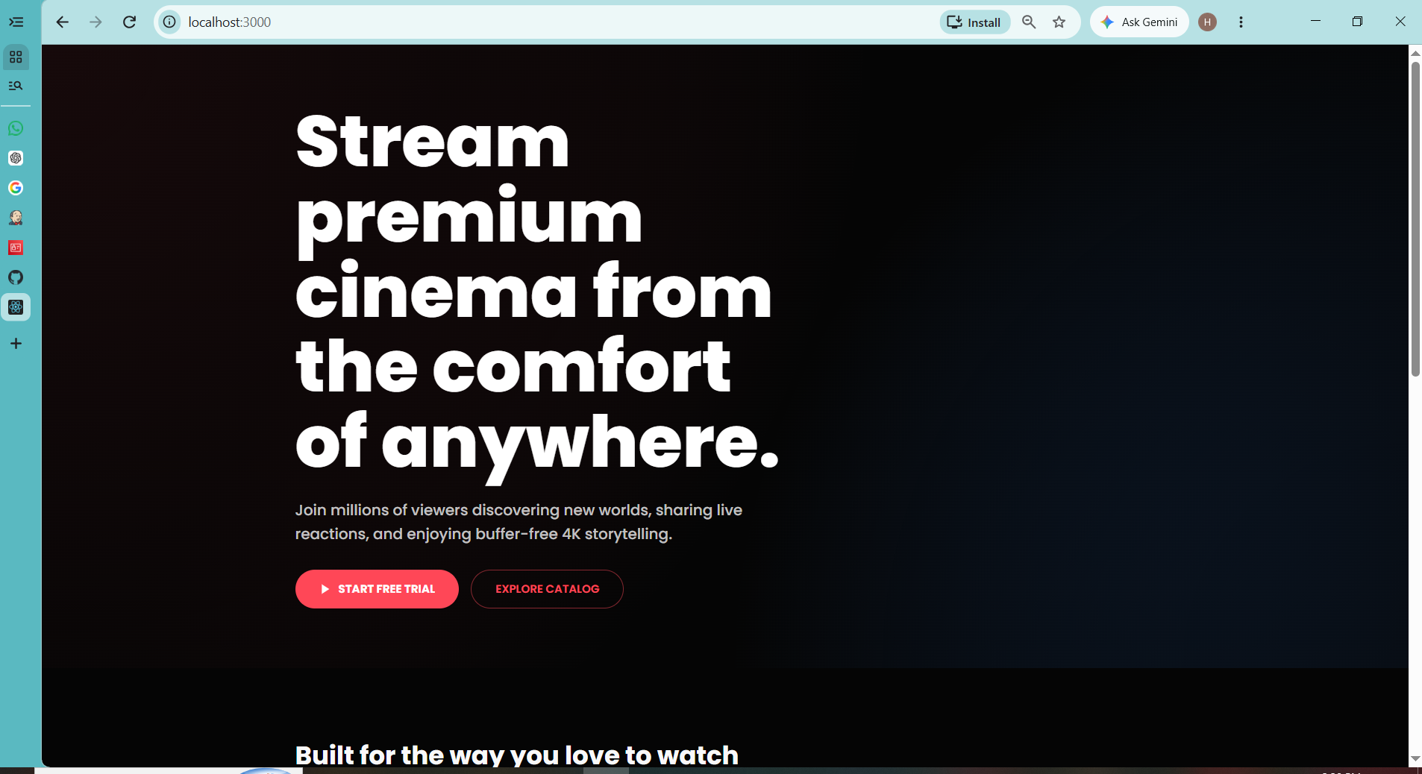

docker compose logs
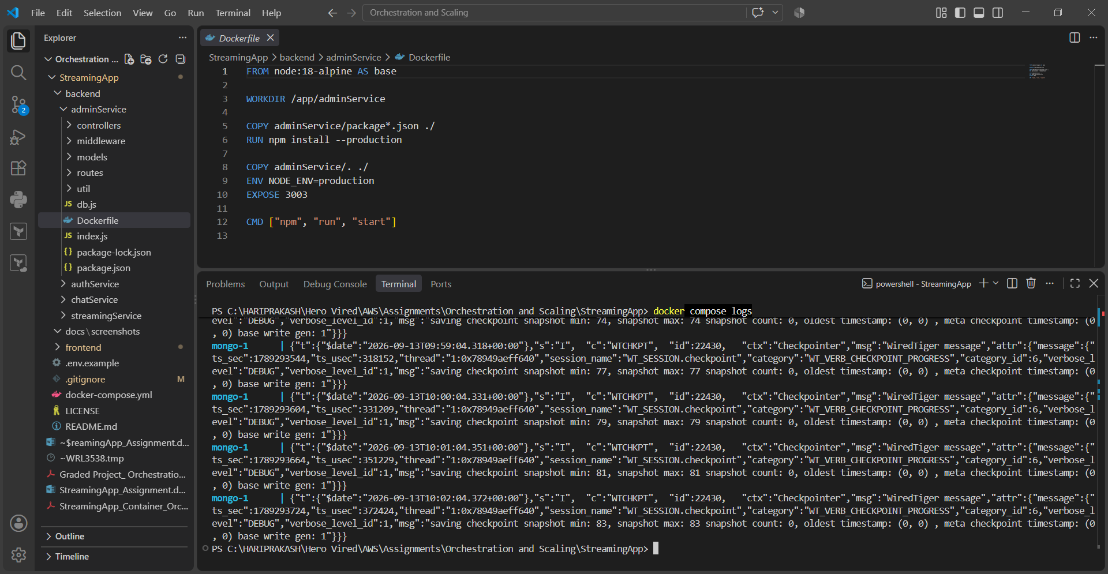
docker compose down
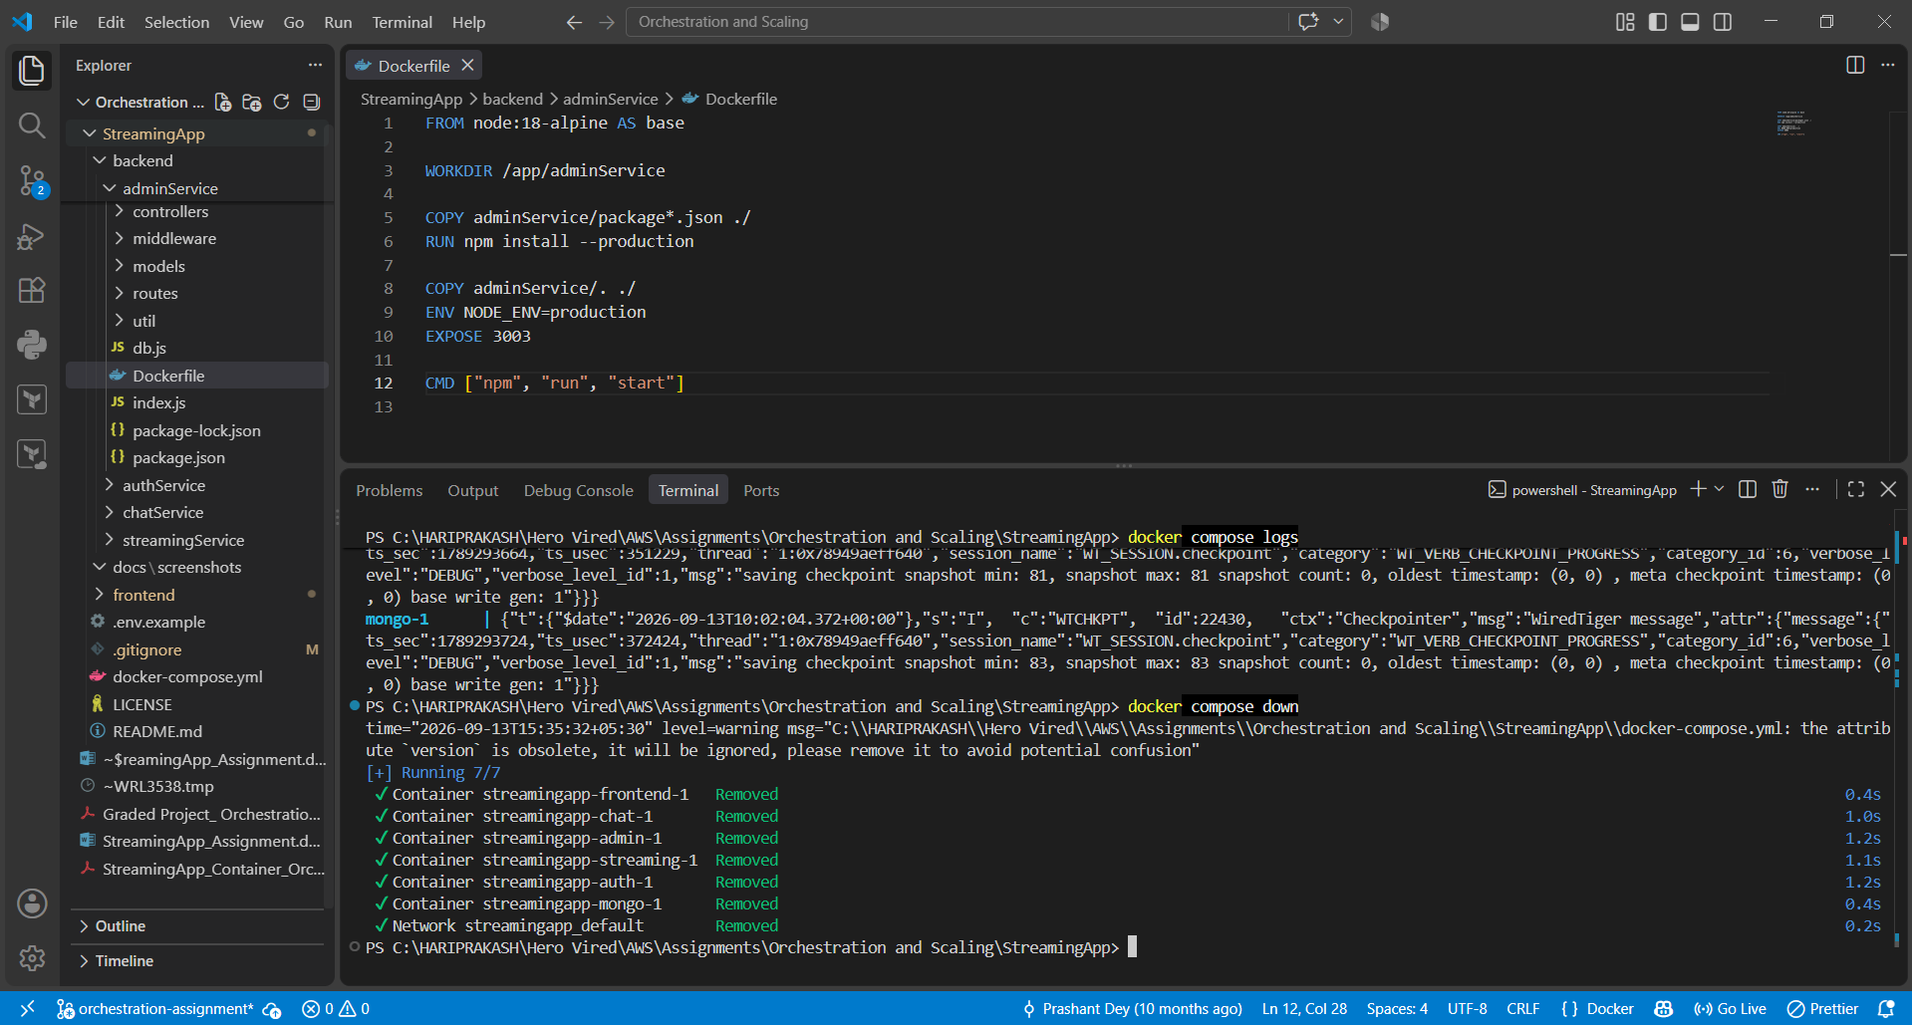

Github repo:
